**(EEL2020)** **DIGITAL DESIGN LAB4 REPORT**

KARTIK CHOUDHARY B20CS025

**Work** 1. Write a Program to implement a

a) BCD Adder Unit

*Test bench*

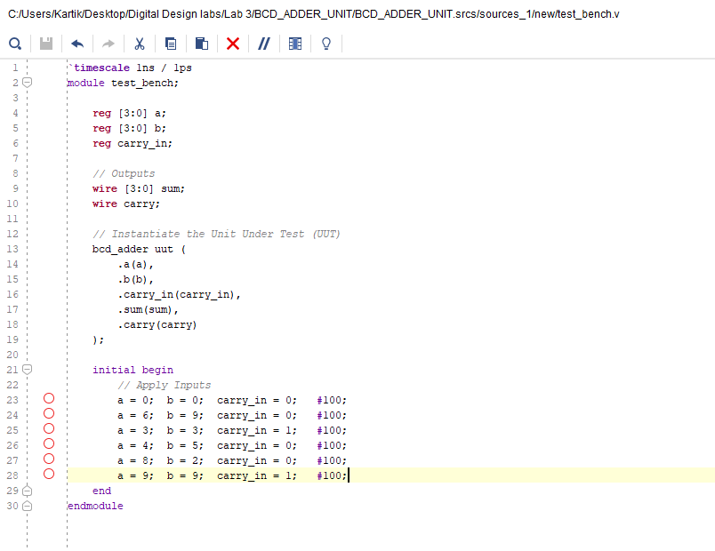

*Verilog Code*

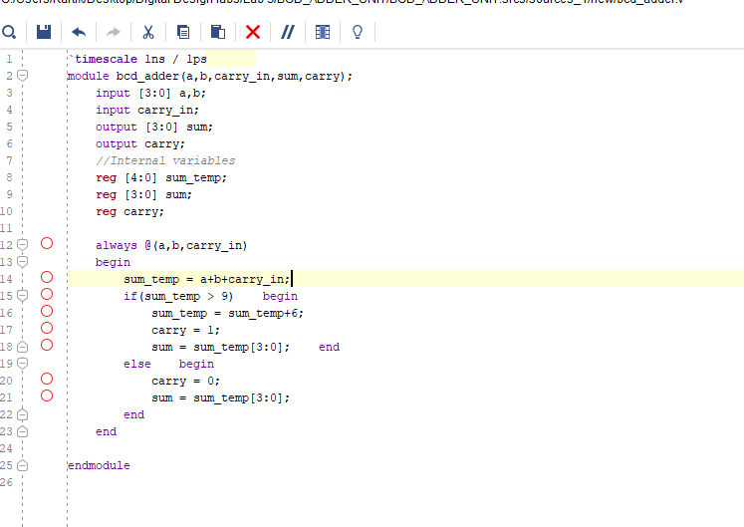

*Waveform*

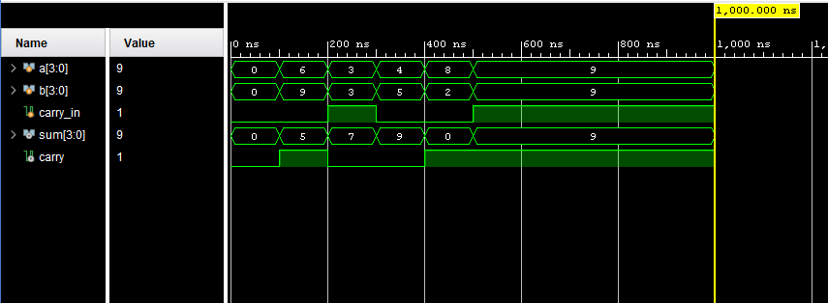

b) BCD Subtractor Unit

*Test Bench*

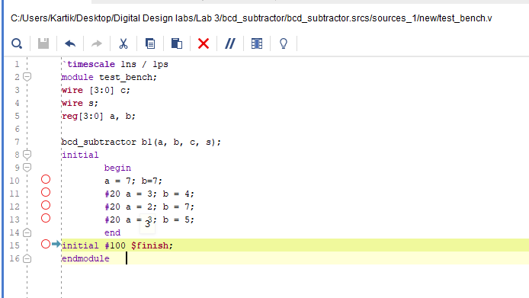

*Verilog Code*

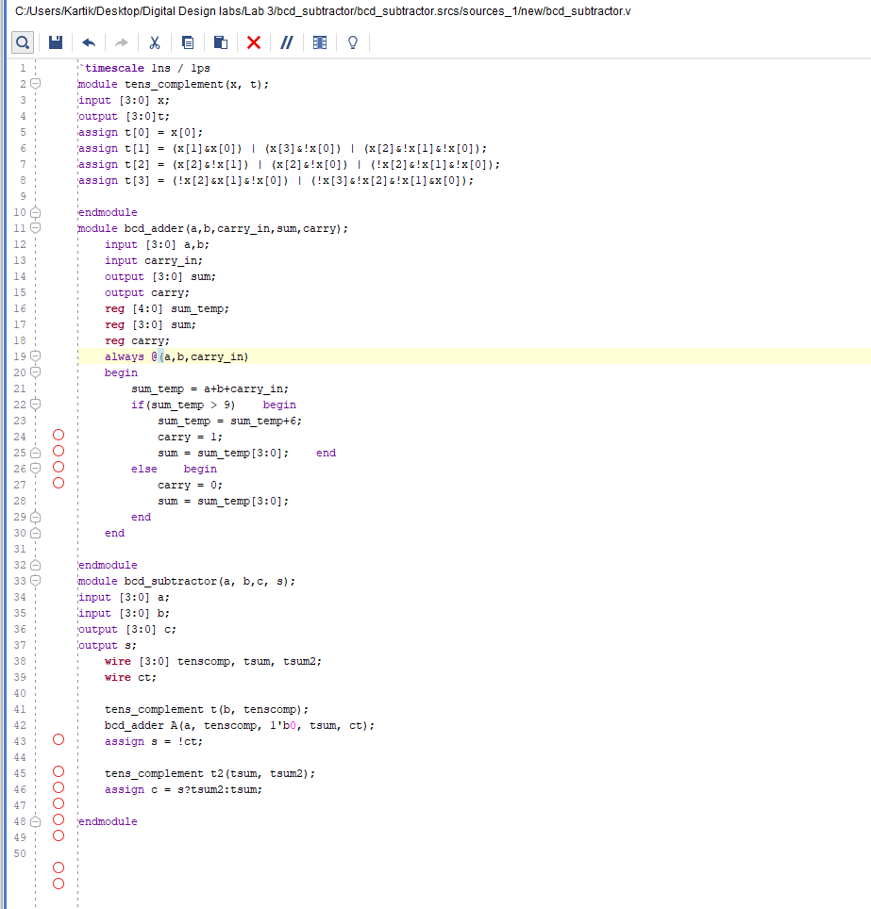

*Waveform*

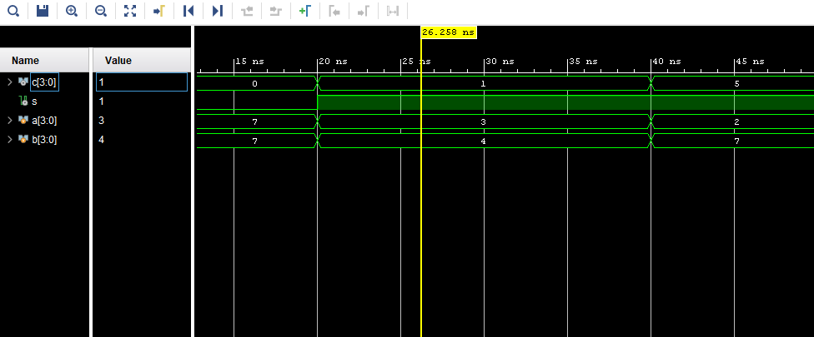

**Work 2: Write a Program to implement a   
a) Binary Multiplier (3-bit X 3-bit): Maximum product = 7X7 = 49  
use input A = A0, A1, A2  
use input B = B0, B1, B2**

*Test Bench*

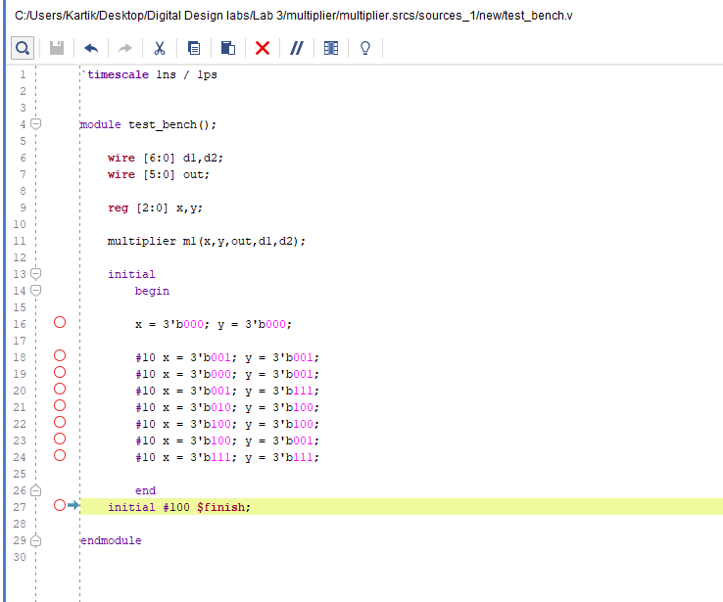

*Verilog Code*

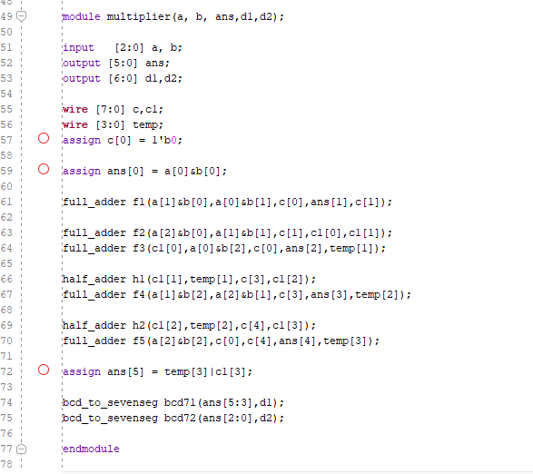

*Waveform*

